Step1. Please insert the red connecter which conduct the positive electricity into the red jack then insert the black connecter which conduct the negative electricity into the black jack. (*PS: the red jack connect with the pantograph)
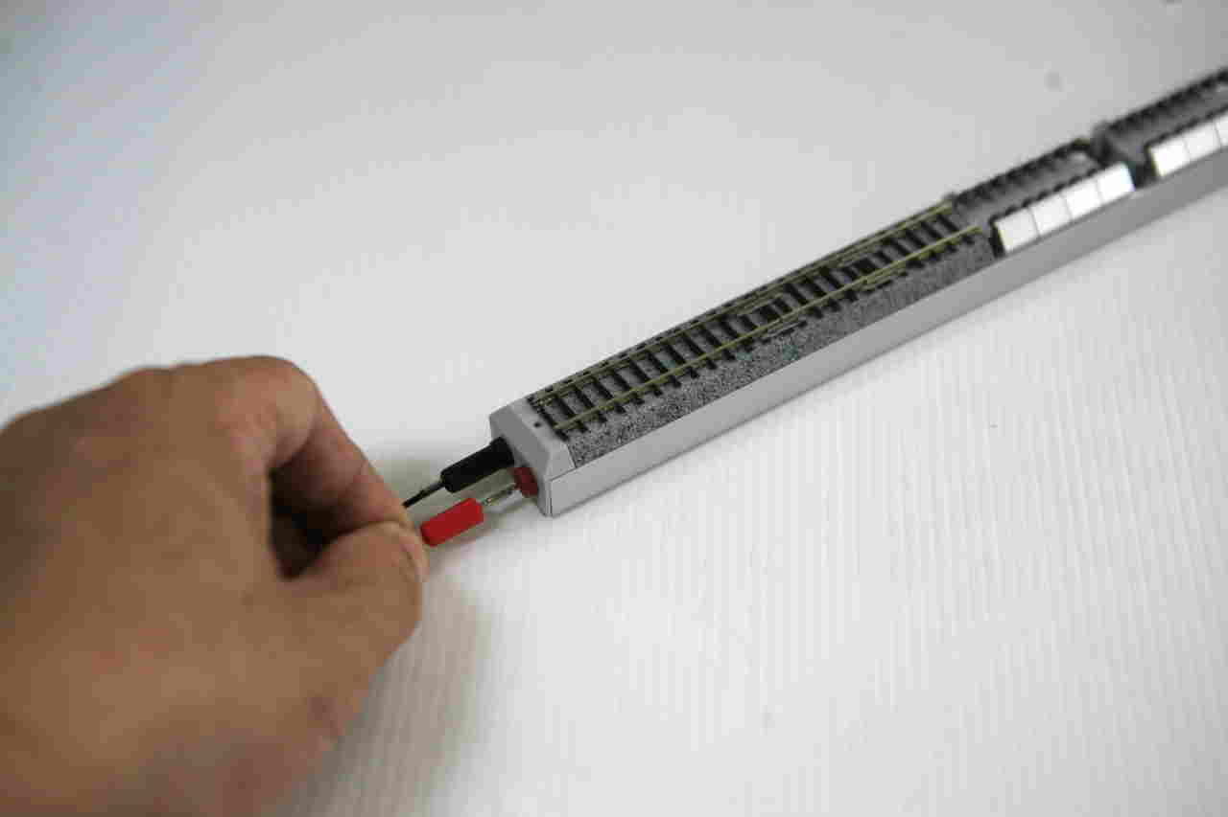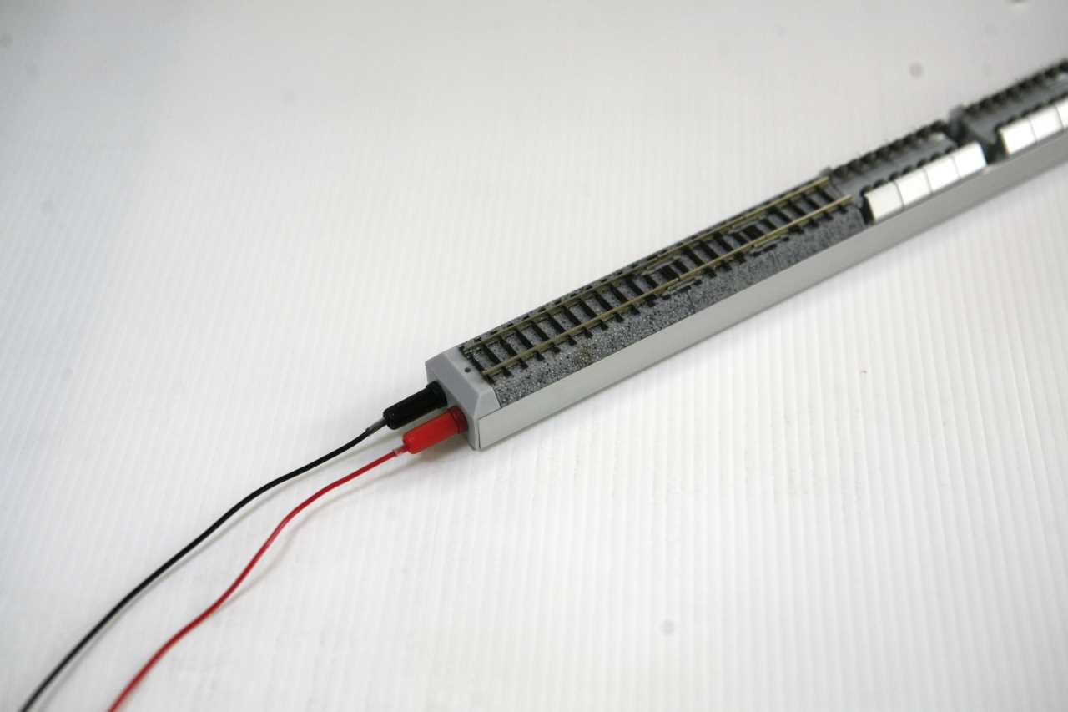

Step 2. Please adjust the assemble tracks for the kind of type locomotive t
Adjust the each assemble tracks to suitable the different type locomotive
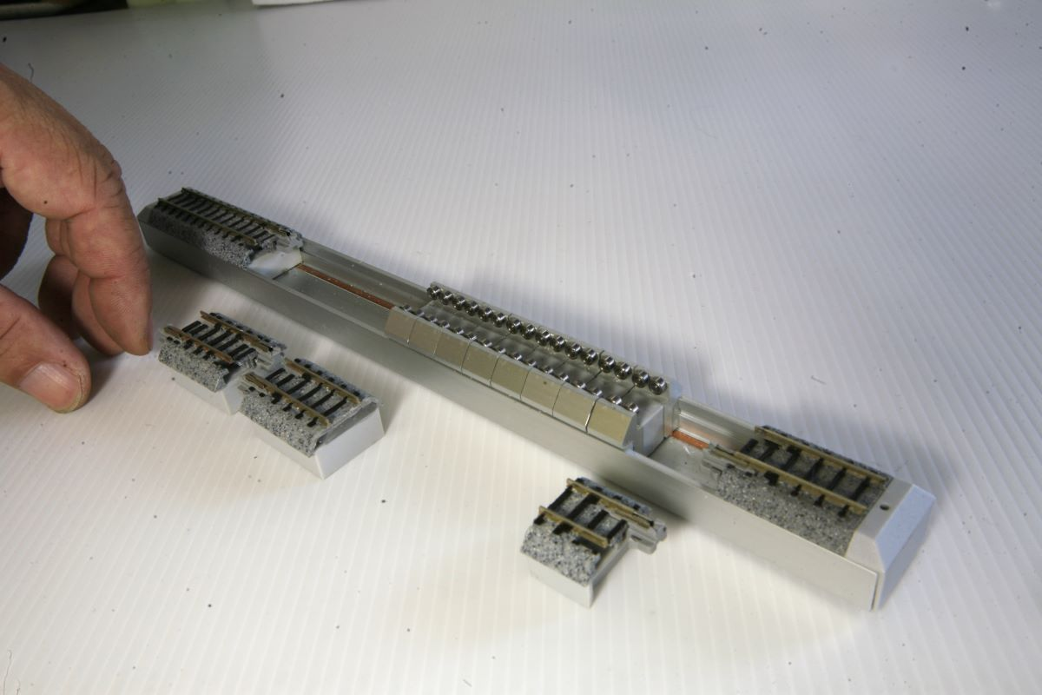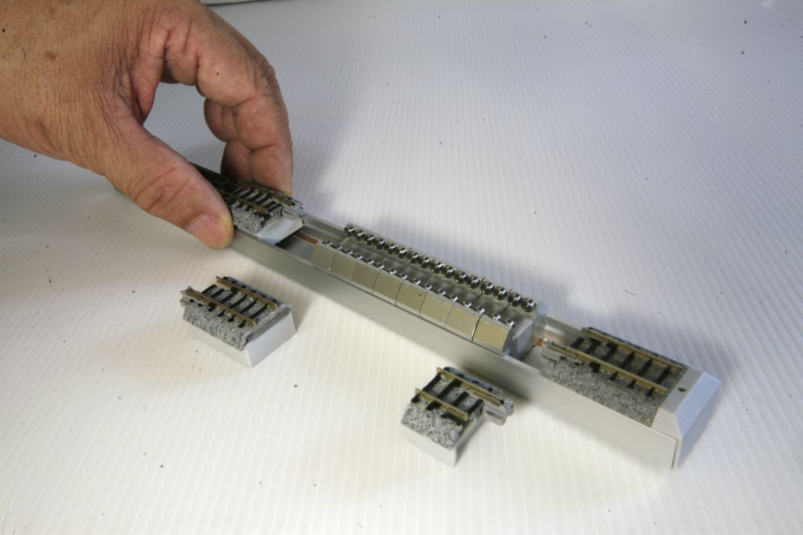
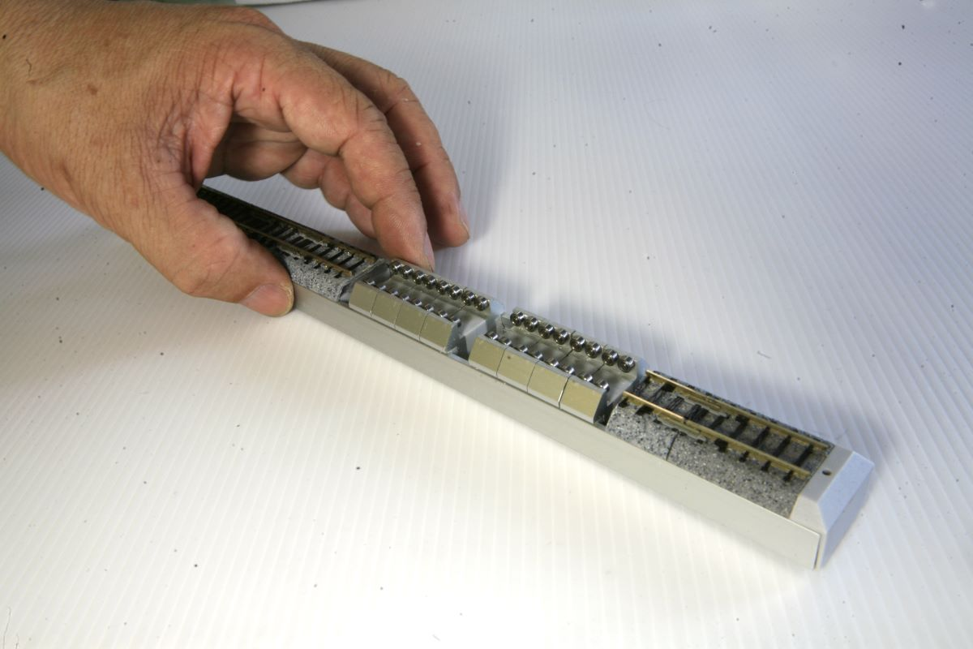

Step 3. Adjust each bearing set gap to suitable the each drive wheel or put the locomotive on the bearing sets directly.
Adjust the bearing set gap Put the locomotive on the bearing sets directly.
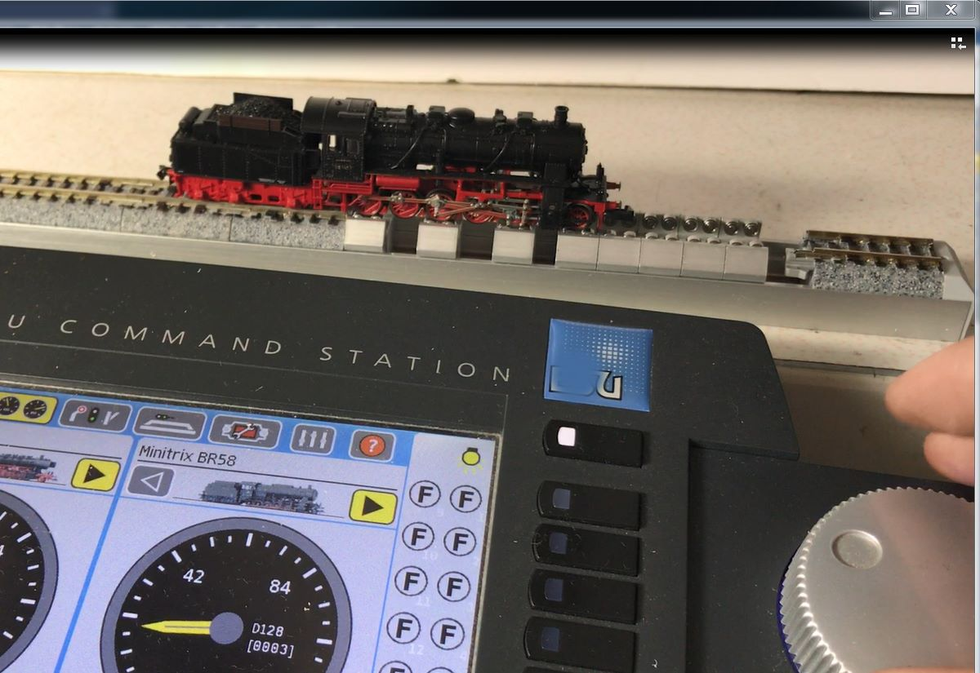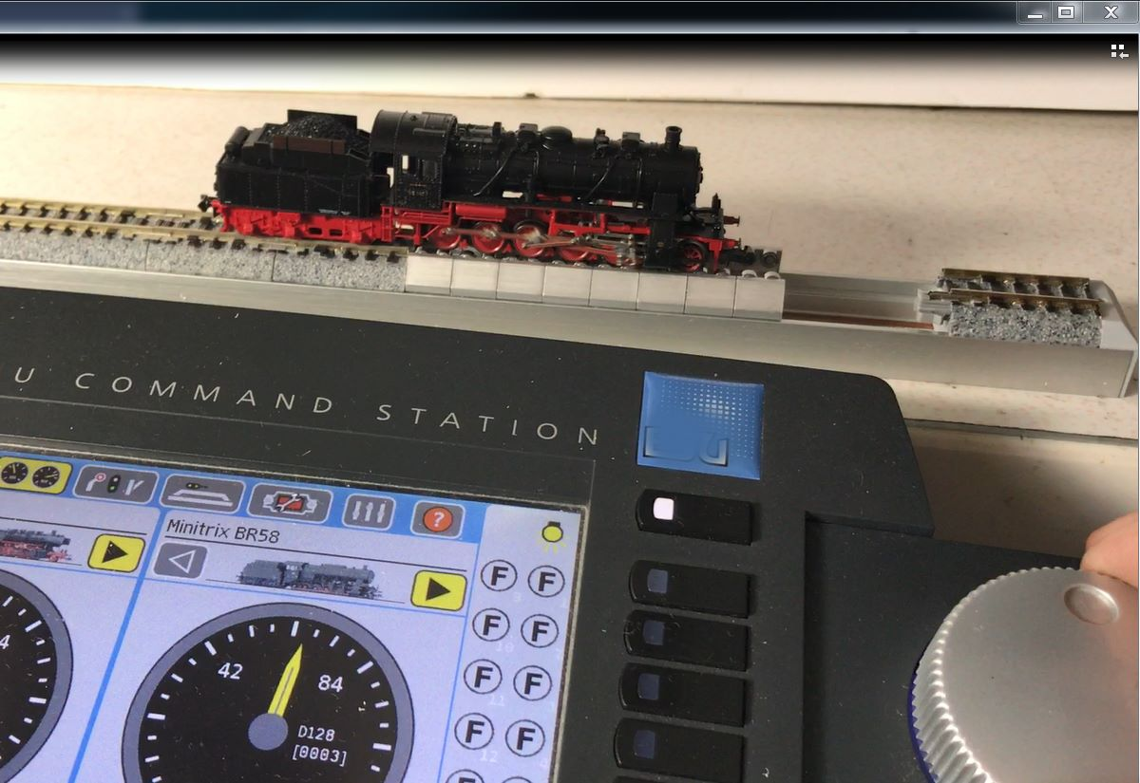

Step 4. Then turn on the power

